|  |
| --- |
| **TRUSTup – application for creating cyber-trust in connected homes** |
| **System Description Document** |
| **Document Version:** 0.3 |
| **Date:** 5/7/2021 |
| **Last edited by:** Rechowicz, Krzysztof J. |
| Developed by W&M and ODU under the Coastal VA Commonwealth Cyber Initiative -- "Trust, Interoperability and Inclusion: A Framework for Creating Cyber-Trust in Connected Homes." |
| Executive Summary The TRUSTup is a software solution for creating cyber-trust in connected homes by implementing a cyber-trust framework that takes into account the 1) manufacturer, configuration and interoperability of devices in a home, 2) the experience, background and position on individuals occupying the space on a spectrum (hearing, vision, physical/motor, and autism) and 3) the content, type, and amount of data being collected, whether disclosed or undisclosed.  TRUSTup comes from the realization modern Western homes are increasingly equipped with smart and connected devices. This multiplication of sensors brings into the home a multitude of multimodal interfaces (voice, web, tactile), hidden tracking, embedded automation, and adaptive learning. As a result, the home of the future is a massive data collection ecosystem that can be misused for economic and financial gain and is vulnerable to cyber-attacks. The homeowner is often unaware of the data being collected or the security risk they face by introducing a new device in their living space. As a result, there is a deficit of trust between smart and connected spaces and the people occupying the space.  This deficit of trust has a critical impact. While a smart home's goal is to adapt to and support its occupants, current devices and algorithms are not trusted to adapt to the diversity of experience, background, preferences, and physical ranges routinely encountered in real life. As a result, people's experiences on a spectrum (hearing, vision, physical/motor, autism) are often not effectively accommodated. The solution is to increase trust between the people, connected objects, and the companies that make them.  To address these challenges, TRUSTup (1) detects and identifies connected IoT devices in the user's home, (2) retrieves, processes, and analyzes associated Privacy Policies (PPs) and Terms of Service (ToS), (3) identifies security-related software flaws and misconfigurations by leveraging the U.S. government repository and social media, (4) presents cyber-trust-related insights to the user through an accessible and inclusive interface. |

Table of Contents

Executive Summary 2

Acronyms and Abbreviations 4

Terms and Definitions 4

1. Introduction 6

2. TRUSTup Overview 6

3. System Architecture 6

3.1 Connected Home 7

3.2 Client mobile application 7

3.3 TRUSTup application 8

3.3.1 Technical Architecture 9

3.3.2 Technology Stack 9

3.3.3 Deployment Architecture 9

3.3.3.1 Application Frontend 10

3.3.3.2 Application Backend 10

3.3.4 Natural Language Processer (NLP) 11

3.3.5 Installation 13

3.3.6 User Interface 14

3.3.7 Accessibility 22

4. Role-Based Access and Permission 26

5. Risks 26

6. Team Organization 27

References 27

# Acronyms and Abbreviations

|  |  |
| --- | --- |
| AI | Artificial Intelligence |
| AWS | Amazon Web Services |
| CCI | Commonwealth Cyber-Initiative |
| COTS | Commercial off-the-shelf |
| ML | Machine Learning |
| PP | Privacy Policy |
| ToS | Terms of Service |
| ToS;DR | Terms of Service; Didn't Read |
| NVD | National Vulnerability Database |
| UI | User Interface |
|  |  |
|  |  |

# Terms and Definitions

|  |  |
| --- | --- |
| Accessibility | The practice of making your websites usable by as many people as possible. |
| Privacy Policy | A statement or legal document that discloses some or all of the ways a party gathers, uses, discloses, and manages a customer or client's data. |
| Terms of Service | The legal agreements between a service provider and a person who wants to use that service. The person must agree to abide by the terms of service in order to use the offered service. Terms of service can also be merely a disclaimer, especially regarding the use of websites. |
| Trust | Firm belief in the reliability, truth, ability, or strength of someone or something. |
| Zero-day | A flaw in software, hardware, or firmware that is unknown to the party or parties responsible for patching or otherwise fixing the flaw. The term zero-day may refer to the vulnerability itself or an attack with zero days between the time the vulnerability is discovered and the first attack. |
| Terms of Service; Didn't Read | A community project aiming to analyze and grade the terms of service and privacy policies of major Internet sites and services. Each aspect of a ToS or privacy policy is assessed as positive, negative, or neutral. |
| EC2 Instance | A remote machine that is hosted by AWS. |
| DynamoDB | A NoSQL database hosted by AWS. |
| Natural Language Processing  RESTful API’s | Natural Language Processing is a subfield of linguistics, computer science, and artificial intelligence concerned with the interactions between computers and human language.  An architectural style for an application program interface that uses HTTP requests to access and use data. |
|  |  |

# Introduction

This System Description Document (SDD) was created to outline the system design for TRUSTup and how it was constructed. SDD was also created to ensure that the TRUSTup design meets the requirements specified in the Trust, Interoperability and Inclusion: A Framework for Creating Cyber-Trust in Connected Homes" project requirements documentation. SDD is also intended to provide context and perspective for current and future team members, customers, and stakeholders. SDD describes the system architecture, software, hardware, database design, and security.

# TRUSTup Overview

TRUSTup is a software solution aimed at increasing cyber-trust between the people, connected objects, and the companies that make them. It is accomplished by implementing the framework for creating cyber-trust in connected homes in the form of a mobile app and a

**TRUSTup integrates seamlessly into the user's current environment. The user can:**

* Utilize TRUSTup to identify all IoT devices connected to the internet through their home network.
* Receive information about scores associated with PPs and TOSs (and the fragments raising concerns) corresponding to the IoT devices.
* Receive information about any reported in the NIST's National Vulnerability Database vulnerabilities associated with the IoT devices.
* Receive information regarding any significant mentions of a zero-day vulnerability on social media associated with the IoT devices.
* Access the information through an accessible UI.

**TRUSTup can scan the local network** to discover IoT devicesand automatically identify the associated vendor.

**TRUSTup can search for PPs and ToS** associated with the IoT devices and the corresponding community-based rating related to how the user's data is handled.

For PPs and ToS that have not been rated by the community, **TRUSTup leverages natural language processing to** identify similar clauses in the database of rated documents and adopt their rating.

**TRUSTup has a modular and extensible software architecture** to support the response to new requirements and to allow seamless integration of state-of-the-art algorithms providing novel analytical and machine learning capabilities.

# System Architecture

At the highest level of abstraction, TRUSTup ecosystem comprises three core components:

* Connected Home
* Client mobile application
* Server-side application

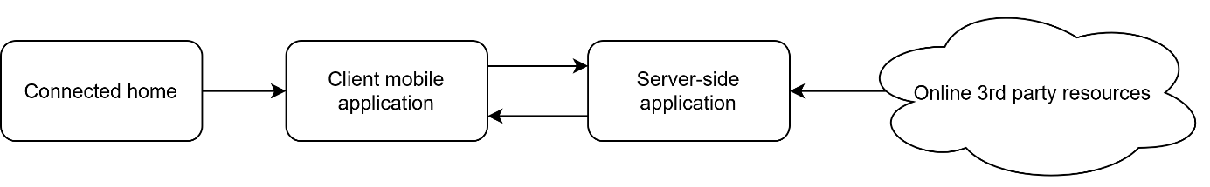

Figure 1. System components.

## Connected Home

Connected home is the place where one lives permanently and connected to the network devices monitor and control home attributes such as lighting, climate, entertainment systems, and appliances. In this context, connected devices carried and worn by homeowners which help them communicate, maintain their health, or monitor physical activity are considered part of the ecosystem. Smart vehicles can be also considered as an extension of connected home.



Figure 2. TRUSTup in the context of the connected home.

## Client mobile application

TRUSTup mobile app provides the following functionality to the user:

1. Scanning the home network for the connected devices.
   1. **Note:** Due to changes in iOS ver. 14+, the scanning has been disabled until the solution is found.
2. Correcting information about the connected devices.
3. Searching the database of IoT devices for a connected home.
4. Storing the information about the connected devices, including the user-added devices.
5. Delivering information about grades and labels associated with PPs and TOSs.
6. Choosing and saving user settings.

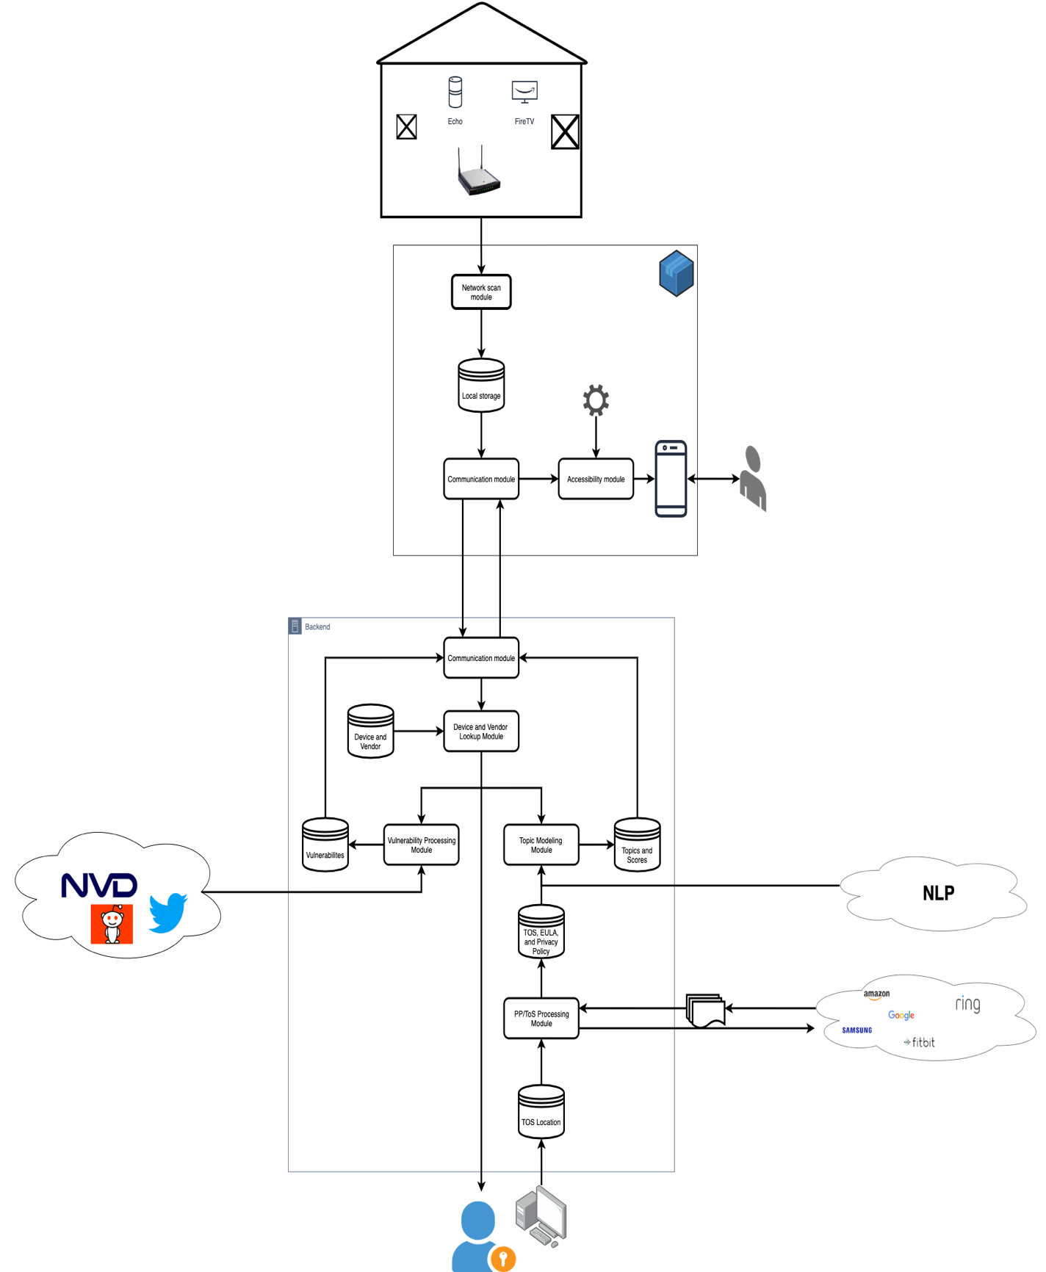

Figure 3. System design diagram.

## TRUSTup application

TRUSTup application backend provides the following functionality:

1. Identifying the device's vendor/manufacturer based on DeviceID.
2. Searching and retrieving PPs and TOSs for the IoT-associated vendors.
3. Searching the ToS;DR (tosdr.org) database for the grades and labels associated with the corresponding PPs and ToSs.
4. For the PPs and ToSs that have not been found in the ToS;DR database, identifying the closest, based on the content and characteristics, PPs and ToS in the ToS;DR database and assignment of the existing grades and labels to the new PPs and ToS.
5. Searching the National Vulnerabilities Database for security-related software flaws and misconfigurations.
6. Searching social media (Twitter and Reddit for zero-day vulnerabilities).
7. Asynchronously and periodically updating the PPs and ToS database.

Table 1. Grades and labels associated with PPs and TOSs based on https://tosdr.org

|  |  |
| --- | --- |
| **Grade** | **Description** |
| Grade A | The best terms of services: they treat the user fairly, respect their rights, and will not abuse their data |
| Grade B | The terms of services are fair towards the user but they could be improved. |
| Grade C | The terms of service are okay but some issues need your consideration. |
| Grade D | The terms of service are very uneven or some important issues need the user's attention. |
| Grade E | The terms of service raise very serious concerns. |
| No Grade Yet | We haven't sufficiently reviewed the terms yet. |

### Technical Architecture

The application’s technical architecture is implemented in Swift for iOS devices with a version of iOS 12.1 or greater. The implementation requires the use of a framework, design system for UI, authentication service, database, deployed cloud backend for communication with the application, and RESTful API’s.

### Technology Stack

The application’s technical stack uses the React Native Framework to implement the front end and React Native Paper for the design system for UI. The authentication service us Auth0 and our database is DynamoDB. The deployed backend contains the Express Server which connects our front end to the DynamoDB and NLP Backend. The application and deployed backend use RESTful APIs to communicate with TOS;DR and Bing Search API.

### Deployment Architecture

This is the architecture for the current deployment of the application. It consists of a frontend and backend the communicate with each other. To deploy the application’s frontend, we received permission from Apple to deploy via their TestFlight program. To deploy the backed we uploaded our services to an AWS EC2.

### Application Frontend

The main components of the application frontend are the Authentication service, TOS;DR API, UI communication Module, and the UI accessibility API and React Native Paper design system. All these components communicated with the UI Communication Module, which queries the EC2.

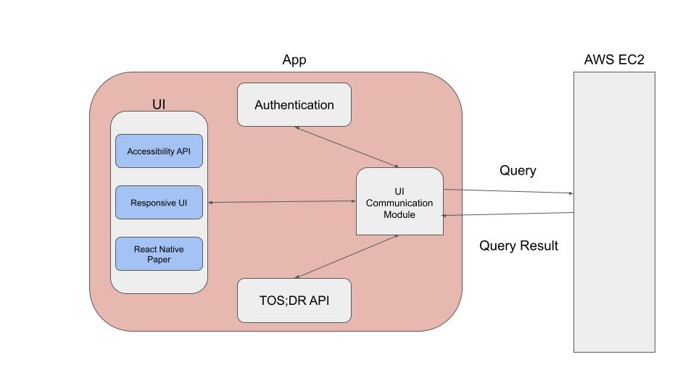

Figure 4. Frontend Architecture

### Application Backend

The main components of the application’s backend cloud deployment are an AWS EC2 instance and AWS DynamoDB database. These components communicate with the application on the user’s phone, processes and return information about the specified query. An example of a query could be a URL, Company Name, or a userID.

If a company is not in the TOS;DR API, we preform our own search to retrieve a PP/TOS URL that is then scraped and graded.

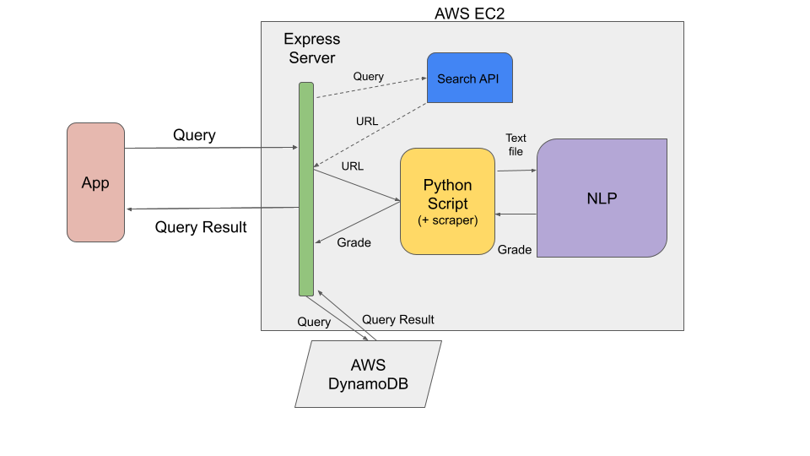

Figure 5. Cloud Architecture

### Natural Language Processer (NLP)

Creates a text classification model for companies that have a grade and privacy policy/terms of service in the TOS;DR database. The preprocessing happens first and involves filtering out any text that contains a digit and is less than 5 letters. The NLP also converts each word to its stem, removes punctuation, and splits the document up by sentences.

Next, a Random Forest Prediction Model is built with TF-IDF weighting as features. Random forest builds multiple decision trees and merges them together to get a more accurate and stable prediction. TFIDF, short for term frequency–inverse document frequency, is a numerical statistic that is intended to reflect how important a word is to a document in a collection. When 99.9% of sparse terms are excluded, random forest builds multiple decision trees and merges them together to get a more accurate and stable prediction. The highest accuracy for the prediction model on data it was not trained on was 48.6%.

Companies that do not have a grade and/or privacy policy/terms of service documents in the TOS;DR database are compared to the existing prediction model. Vendor probabilities are generated for the company that is being compared to the existing companies. For example, if the CellarTracker terms of service is being compared (doesn’t have a grade) the vendor probabilities look like this:

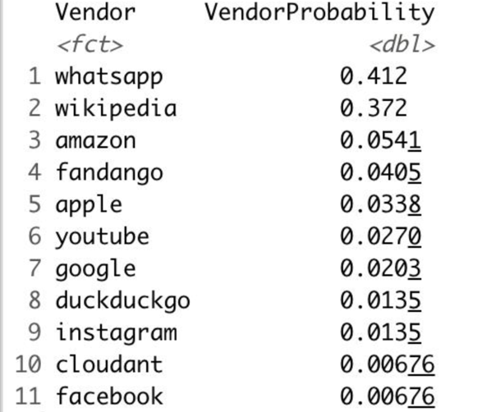

Figure 6. TOS Document Summary

CellarTracker’s grade of D is calculated using weighting based on the grades of companies in the vendor probability. In this case, 41.2% of Whatsapp (Grade: E), 37.2% of Wikipedia (Grade: C), 5.41% of Amazon (Grade: D), etc.

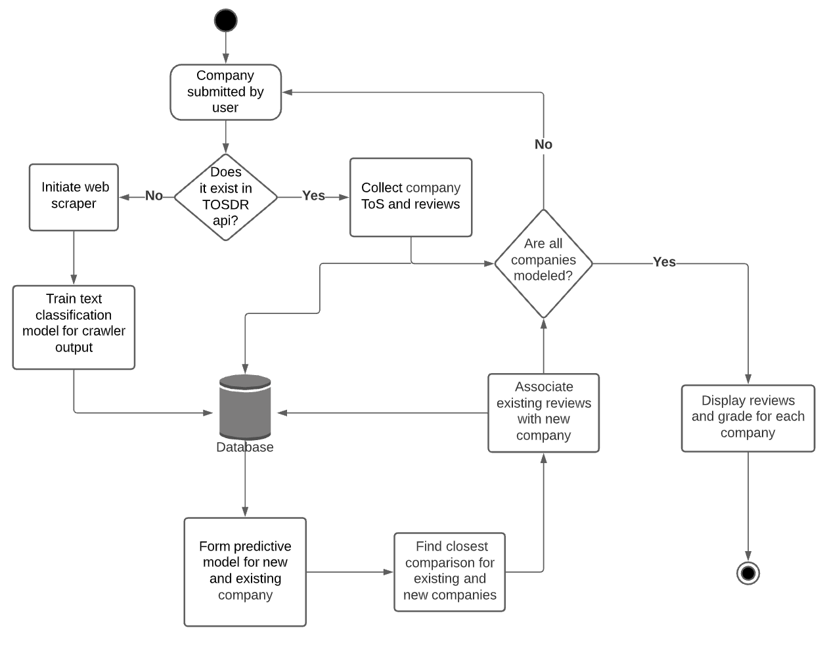

Figure 7.

### Installation

Installation requires a user to install Apple’s TestFlight application, once installed a user must open the invitation link provided which will launch Apple’s TestFlight application that displays the screen shown in Figure 8. The user must accept the invitation and then prompted to install the application which is shown in Figure 9. The application will install similarly to an application you download from the Apple App Store.

Invitation Link: <https://testflight.apple.com/join/QozbzZUE>

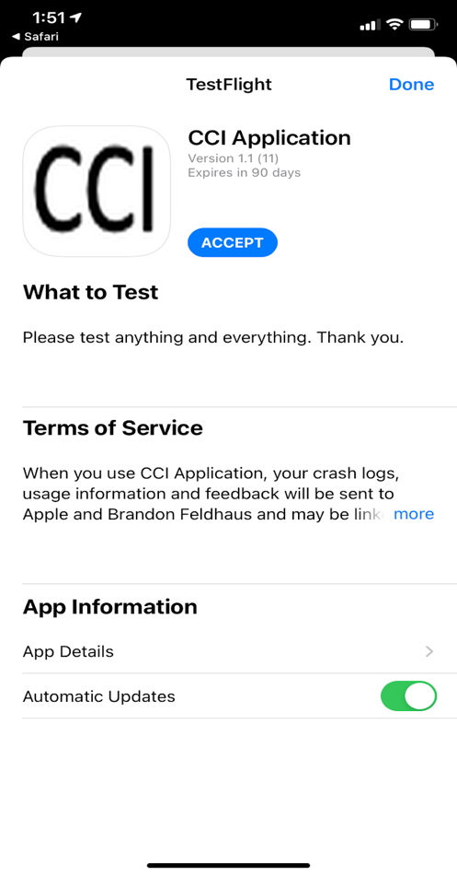

Figure 8. Invitation

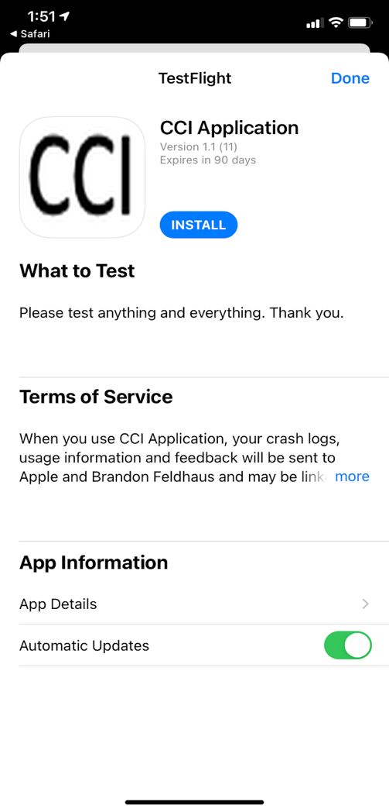

Figure 9. Application Installation

### User Interface

When a user opens the application, they are displayed the login page shown in Figure 10. On this page they will have two options to sign in with, Google or Apple. When a user selects a sign in choice, they are prompted with the message shown in Figure 11, from here the user must select “Continue” which launches the chosen sign in portal.

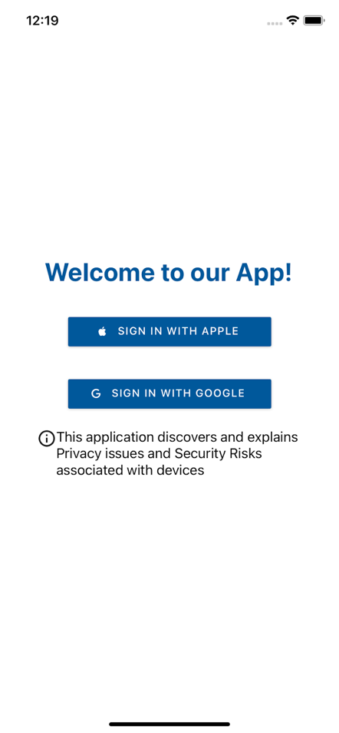

Figure 10. Login Page

Figure 11. Login Authorization

Once a user has logged into the application, they are presented with the Home page which is shown in Figure 12. If this is not the users first time logging in, they will be presented with their company list shown in Figure 13.

From the home screen the user has the option to:

* Add a Company,
* Tap on a Company item in their list,
* Logout of the application,
* Navigate to application’s Additional Information page,
* And navigate to the applications GitHub wiki page.

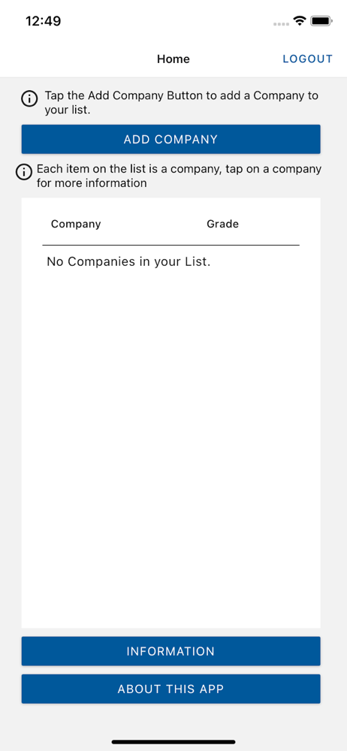

Figure 12. Home Page

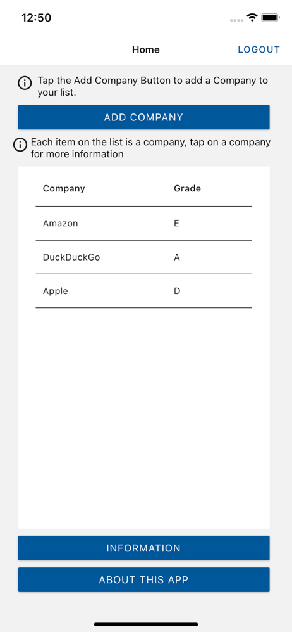

Figure 13. Home Page Populated List

In order to add a company to the users list they must tap the Add Company button which launches our Add Company page that is shown in Figure 14. A user must input a company name and tap the submit button which launches the loading page shown in Figure 15. Once our process of retrieving the grade and privacy policy information is complete the user will be taken back to the Home page where they will find the newly added item to their company list. If a user chooses to tap the back button while on the Loading page they are prompted with an alert notifying them of lost information if they leave shown in Figure 16.

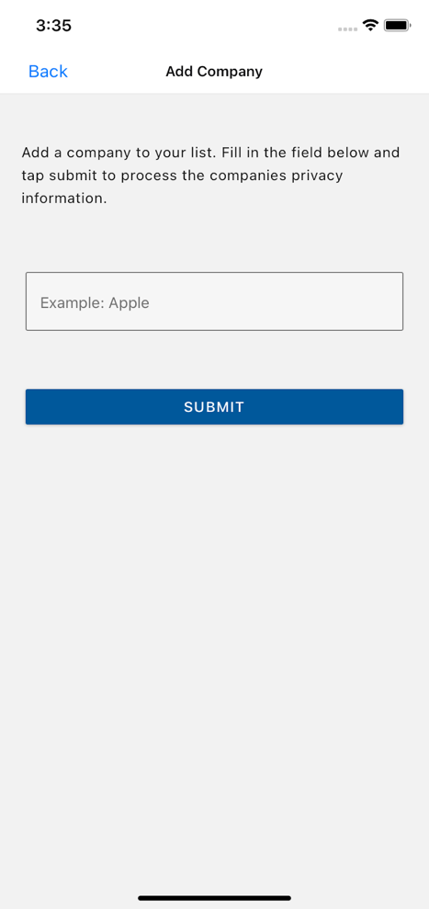

Figure 14. App Company Page

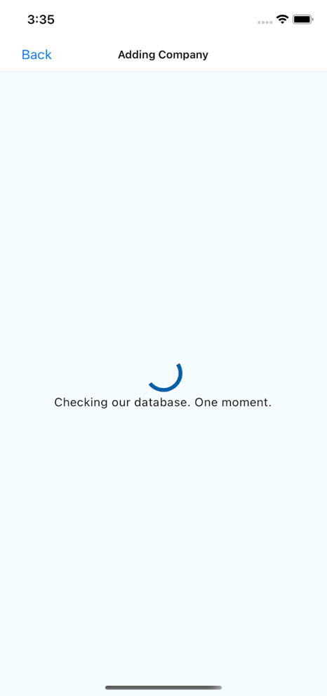

Figure 15. Loading Page

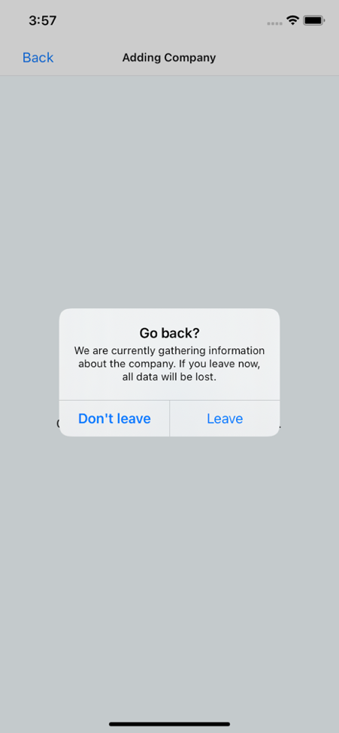

Figure 16. Lost Information Alert

For the user to find out more information about the company they just added to their list, they must tap on that company item in the list to navigate to the Company page. Figures 17 and 18 show examples of two different company pages. Every company page will consist of the document type, timestamp, name of company, grade, reason for the grade, link to any TOS;DR and reviews.

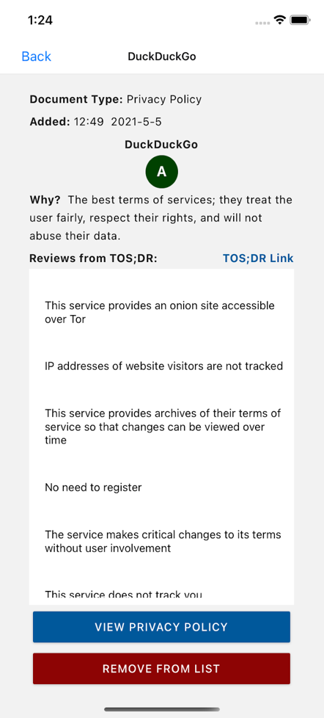

Figure 17. Company Page 1

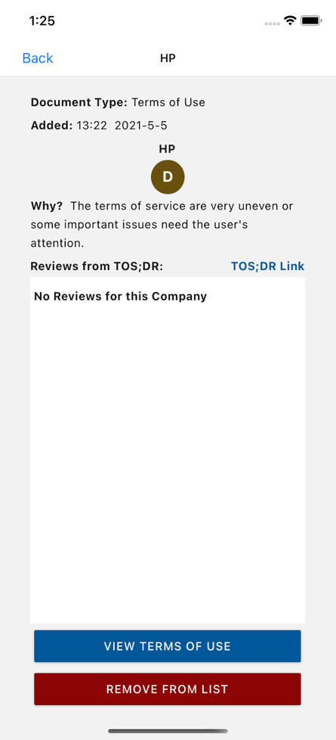

Figure 18. Company Page 2

If a user wishes to learn more information on definition of terms used and how grades are calculated they must tap the Information button on the Home page. This will launch the Information page which is shown in Figure 19.

If a user wishes to learn more information about the developers of the application or about general information, they must tap the “About this App” button on the Home page. This will take the user out of the application and to a GitHub Wiki shown in Figure 20.

Figure 19. Information Page

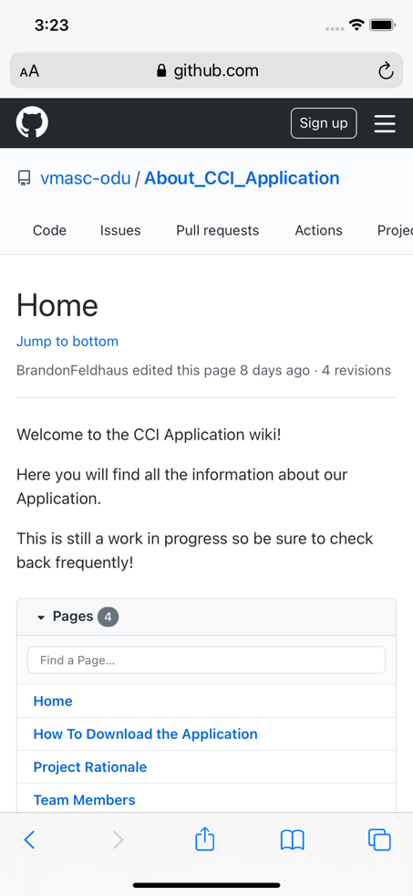

Figure 20. GitHub Wiki

### Accessibility

Achieved AAA Web Content Accessibility Guidelines compliance using a WCAG Compliance Checklist (<https://www.wuhcag.com/wcag-checklist/>). A Contrast Checker was used to determine whether colors were up to a certain ratio, such as 7:1 ([Luminosity Colour Contrast Ratio Analyser](https://juicystudio.com/services/luminositycontrastratio.php#specify)).

All non-text content and captioning guidelines are not applicable because the application does not have any video or audio content. The purpose for all components, any strange words, and abbreviations are explained on the “Information” page and the microcopies that are included throughout the application. All information is presented in text form, meaning no images are used for text content. Users can also manipulate text size and device orientation without loss of content or function. We used iOS settings to resize text and manipulate the styling accordingly.

Each page has a heading and is accessible in two different ways. For example, clicking the “Back” button or swiping right to will navigate the user from the “Apple” page to the home page. The risk of all input errors is reduced with the iOS autocorrect feature and the placeholder in the textbox “Example: Apple” for the “Add Company” page.

**WCAG Compliance Checklist:**

**WCAG Checklist Level A (Beginner)**

|  |  |
| --- | --- |
| **Guideline** | **Summary** |
| **N/A** [1.1.1 – Non-text Content](https://www.wuhcag.com/non-text-content/) | Provide text alternatives for non-text content that serves the same purpose. |
| **N/A** [1.2.1 – Audio-only and Video-only (Pre-recorded)](https://www.wuhcag.com/audio-only-video-only-prerecorded/) | Provide an alternative to video-only and audio-only content. |
| **N/A**  [1.2.2 – Captions (Pre-recorded)](https://www.wuhcag.com/captions-prerecorded/) | Provide captions for videos with audio. |
| **N/A** [1.2.3 – Audio Description or Media Alternative (Pre-recorded)](https://www.wuhcag.com/audio-description-media-alternative-prerecorded/) | Provide audio description or text transcript for videos with sound. |
| ✔ [1.3.1 – Info and Relationships](https://www.wuhcag.com/info-and-relationships/) | Content, structure and relationships can be programmatically determined. |
| ✔ [1.3.2 – Meaningful Sequence](https://www.wuhcag.com/meaningful-sequence/) | Present content in a meaningful order. |
| ✔ [1.3.3 – Sensory Characteristics](https://www.wuhcag.com/sensory-characteristics/) | Instructions don’t rely solely on sensory characteristics. |
| ✔ [1.4.1 – Use of Color](https://www.wuhcag.com/use-of-colour/) | Don’t use presentation that relies solely on color. |
| ✔ [1.4.2 – Audio Control](https://www.wuhcag.com/audio-control/) | Don’t play audio automatically. |
| ✔ [2.1.1 – Keyboard](https://www.wuhcag.com/keyboard/) | All functionality is accessible by keyboard with no specific timings. |
| **N/A** [2.1.2 – No Keyboard Trap](https://www.wuhcag.com/no-keyboard-trap/) | Users can navigate to and from all content using a keyboard. |
| **N/A** [2.1.4 – Character Key Shortcuts](https://www.wuhcag.com/character-key-shortcuts/) | Allow users to turn off or remap single-key character shortcuts. |
| **N/A** [2.2.1 – Timing Adjustable](https://www.wuhcag.com/timing-adjustable/) | Provide user controls to turn off, adjust or extend time limits. |
| ✔ [2.2.2 – Pause, Stop, Hide](https://www.wuhcag.com/pause-stop-hide/) | Provide user controls to pause, stop and hide moving and auto-updating content. |
| ✔ [2.3.1 – Three Flashes or Below Threshold](https://www.wuhcag.com/three-flashes-or-below-threshold/) | No content flashes more than three times per second. |
| ✔ [2.4.1 – Bypass Blocks](https://www.wuhcag.com/bypass-blocks/) | Provide a way for users to skip repeated blocks of content. |
| ✔ [2.4.2 – Page Titled](https://www.wuhcag.com/page-titled/) | Use helpful and clear page titles. |
| ✔ [2.4.3 – Focus Order](https://www.wuhcag.com/focus-order/) | Components receive focus in a logical sequence. |
| ✔ [2.4.4 – Link Purpose (In Context)](https://www.wuhcag.com/link-purpose-in-context/) | Every link’s purpose is clear from its text or context. |
| **N/A** [2.4.7 – Focus Visible](https://www.wuhcag.com/focus-visible/) | Keyboard focus is visible when used. |
| ✔ [3.1.1 – Language of Page](https://www.wuhcag.com/language-of-page/) | Page has a language assigned |
| ✔ [3.2.1 – On Focus](https://www.wuhcag.com/on-focus/) | Elements do not change when they receive focus |
| ✔ [3.2.2 – On Input](https://www.wuhcag.com/on-input/) | Elements do not change when they receive input |
| ✔ [3.3.1 – Error Identification](https://www.wuhcag.com/error-identification/) | Clearly identify input errors |
| ✔ [3.3.2 – Labels or Instructions](https://www.wuhcag.com/labels-or-instructions/) | Label elements and give instructions |
| ✔ [4.1.1 – Parsing](https://www.wuhcag.com/parsing/) | No major code errors |
| ✔ [4.1.2 – Name, Role, Value](https://www.wuhcag.com/name-role-value/) | Build all elements for accessibility |

**WCAG Checklist Level AA (Intermediate)**

|  |  |
| --- | --- |
| **Guideline** | **Summary** |
| **N/A** [1.2.4 – Captions (Live)](https://www.wuhcag.com/captions-live/) | Add captions to live videos. |
| **N/A** [1.2.5 – Audio Description (Pre-recorded)](https://www.wuhcag.com/audio-description-prerecorded/) | Provide audio descriptions for pre-recorded videos. |
| ✔ [1.3.4 – Orientation](https://www.wuhcag.com/orientation/) | Your website adapts to portrait and landscape views. |
| ✔ [1.3.5 – Identify Input Purpose](https://www.wuhcag.com/identify-input-purpose/) | The purpose of input fields must be programmatically determinable. |
| ✔ [1.4.3 – Contrast (Minimum)](https://www.wuhcag.com/contrast-minimum/) | Contrast ratio between text and background is at least 4.5:1. |
| ✔ [1.4.4 – Resize Text](https://www.wuhcag.com/resize-text/) | Text can be resized to 200% without loss of content or function. |
| ✔ [1.4.5 – Images of Text](https://www.wuhcag.com/images-of-text/) | Don’t use images of text. |
| ✔ [1.4.10 – Reflow](https://www.wuhcag.com/reflow/) | Content retains meaning and function without scrolling in two dimensions. |
| ✔ [1.4.11 – Non-Text Contrast](https://www.wuhcag.com/non-text-contrast/) | The contrast between user interface components, graphics and adjacent colors is at least 3:1. |
| ✔ [1.4.12 – Text Spacing](https://www.wuhcag.com/text-spacing/) | Content and function retain meaning when users change elements of text spacing. |
| **N/A** [1.4.13 – Content on Hover or Focus](https://www.wuhcag.com/content-on-hover-or-focus/) | When hover or focus triggers content to appear, it is dismissible, hoverable and persistent. |
| ✔ [2.4.5 – Multiple Ways](https://www.wuhcag.com/multiple-ways/) | Offer at least two ways to find pages on your website. |
| ✔ [2.4.6 – Headings and Labels](https://www.wuhcag.com/headings-and-labels/) | Headings and labels describe topic or purpose. |
| **N/A** [3.1.2 – Language of Parts](https://www.wuhcag.com/language-of-parts/) | Tell users when the language on a page changes |
| ✔ [3.2.3 – Consistent Navigation](https://www.wuhcag.com/consistent-navigation/) | Use menus consistently |
| ✔ [3.2.4 – Consistent Identification](https://www.wuhcag.com/consistent-identification/) | Use icons and buttons consistently |
| ✔ [3.3.3 – Error Suggestion](https://www.wuhcag.com/error-suggestion/) | Suggest fixes when users make errors |
| ✔ [3.3.4- Error Prevention (Legal, Financial, Data)](https://www.wuhcag.com/error-prevention-legal-financial-data/) | Reduce the risk of input errors for sensitive data |

**WCAG Checklist Level AAA (Advanced)**

|  |  |
| --- | --- |
| **Guideline** | **Summary** |
| **N/A** [1.2.6 – Sign Language (Pre-recorded)](http://www.wuhcag.com/sign-language-pre-recorded/) | Provide sign language translations for pre-recorded videos. |
| **N/A** [1.2.7 – Extended Audio description (Pre-recorded)](https://www.wuhcag.com/extended-audio-description-pre-recorded/) | Provide extended audio descriptions for pre-recorded videos. |
| **N/A** [1.2.8 – Media Alternative (Pre-recorded)](https://www.wuhcag.com/media-alternative-pre-recorded/) | Provide text alternatives for pre-recorded videos. |
| **N/A** [1.2.9 – Audio Only (Live)](https://www.wuhcag.com/audio-only-live/) | Provide alternatives for live audio. |
| ✔[1.3.6 – Identify Purpose](https://www.wuhcag.com/identify-purpose/) | The purpose of all components must be programmatically determinable. |
| ✔ [1.4.6 – Contrast (Enhanced)](https://www.wuhcag.com/contrast-enhanced) | Contrast ratio between text and background is at least 7:1. |
| **N/A** [1.4.7 – Low or No Background Audio](https://www.wuhcag.com/low-or-no-background-audio/) | Audio-only content is clear with no or minimal background noise. |
| ✔ [1.4.8 – Visual Presentation](https://www.wuhcag.com/visual-presentation/) | Offer users a range of presentation options for blocks of text. |
| ✔[1.4.9 – Images of Text (No Exception)](http://www.wuhcag.com/images-of-text-no-exception/) | Don’t use images of text. |
| **N/A** [2.1.3 – Keyboard (No Exception)](https://www.wuhcag.com/keyboard-no-exception/) | All functionality is accessible by keyboard with no exceptions. |
| **N/A** [2.2.3 – No Timing](https://www.wuhcag.com/no-timing/) | No time limits on your website. |
| **N/A** [2.2.4 – Interruptions](https://www.wuhcag.com/interruptions/) | Users can postpone or suppress non-emergency interruptions. |
| ✔[2.2.5 – Re-authenticating](https://www.wuhcag.com/re-authenticating/) | Save user data when re-authenticating. |
| ✔ [2.2.6 – Timeouts](https://www.wuhcag.com/timeouts/) | Warn users about timeouts that cause data loss. |
| ✔[2.3.2 – Three Flashes](https://www.wuhcag.com/three-flashes/) | No content flashes more than three times per second. |
| ✔ [2.3.3 – Animation from Interactions](https://www.wuhcag.com/animation-from-interactions/) | Users can disable motion animation. |
| ✔[2.4.8 – Location](https://www.wuhcag.com/location/) | Let users know where they are on your website. |
| ✔ [2.4.9 – Link Purpose (Link Only)](https://www.wuhcag.com/link-purpose-link-only/) | Every link’s purpose is clear from its text. |
| ✔[2.4.10 – Section Headings](https://www.wuhcag.com/section-headings/) | Organize content with headings. |
| ✔[3.1.3 – Unusual words](https://www.wuhcag.com/unusual-words/) | Explain any strange words |
| ✔ [3.1.4 – Abbreviations](https://www.wuhcag.com/abbreviations/) | Explain any abbreviations |
| ✔ [3.1.5 – Reading Level](https://www.wuhcag.com/reading-level/) | Users with nine years of school can read your content |
| ✔ [3.1.6 – Pronunciation](https://www.wuhcag.com/pronunciation/) | Explain any words that are hard to pronounce |
| ✔[3.2.5 – Change on Request](https://www.wuhcag.com/change-on-request/) | Don’t change elements on your website until users ask |
| ✔ [3.3.5 – Help](https://www.wuhcag.com/help/) | Provide detailed help and instructions |
| ✔ [3.3.6 – Error Prevention (All)](https://www.wuhcag.com/error-prevention-all/) | Reduce the risk of all input errors |

Contrast Ratios:

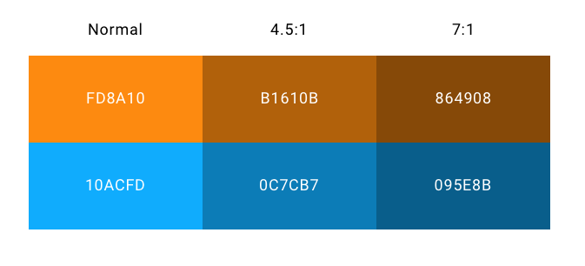

Figure 21. Contrast Ratio.

# Role-Based Access and Permission

* User
* Admin
* Researcher
* Developer

# Risks

As with any complex system construction project, there are risks.

|  |  |  |  |  |
| --- | --- | --- | --- | --- |
| **ID** | **Risk Description** | **Potential Impact** | **Mitigation Activities** | **Status** |
| 1 | The students have insufficient development experience. | The app and its components are delivered with delay or in unsatisfying quality. | The students will be provided access to professional developers and practitioners. The students will be reimbursed for the training necessary to complete the task successfully. | Risk is medium to occur. |
| 2 | The student team is disconnected from the researchers working with the potential end-users. | The app does not meet the requirements of the end-users. | The research team (Dr. Blackmon and Wittkower) will be invited twice a month (or more often) to the weekly development meeting. They will update the student team and their advisors on the findings, requirements, and any relevant to the development information during the meetings. | Risk is high to occur. |
| 3 | The requirements and information about the end-users are not provided on time or are changed continuously. | The app and its components are delivered with delay and do not meet the requirements of the end-users. | The development will focus on limited functionality delivering the highest value that meets the grant requirement and allows to seek more funding to develop a more robust app. | Risk is medium to high. |
| 4 | The student team will be required to work remotely. | The app and its components are delivered with delay or in unsatisfying quality. | The students will be provided with collaboration tools: MS Teams, GitHub, zoom, Whiteboard, etc. The Technical Lead will hold weekly meetings and additional meetings as needed by the students. The students will be given additional access to their mentors as needed. | Risk is very high. VMASC encourages telework for all personnel. |

# Team Organization

TRUSTup is a collaboration between the College of William & Mary and Old Dominion University (ODU). The ODU team is comprised of the Department of Philosophy & Religious Studies and the Virginia Modeling, Analysis, and Simulation Center.

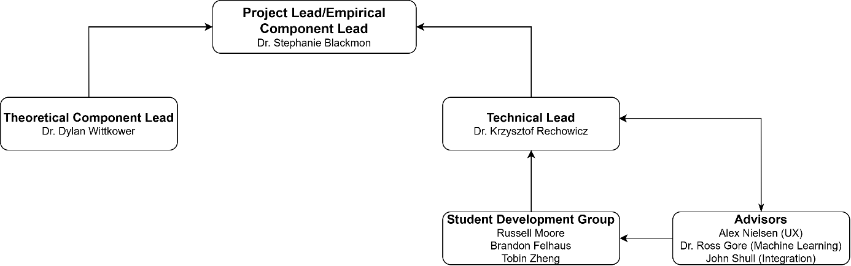

Figure 22. Organization chart.

# References